**Project Planning Phase**

**Project Planning Template (Product Backlog, Sprint Planning ,Story points)**

|  |  |
| --- | --- |
| Date | NOVEMBER 2022 |
| Team ID | PNT2022TMID46337 |
| Project Name | Crude Oil Price Prediction |
| Maximum Marks | 8 Marks |

**Product Backlog, Sprint Schedule, and Estimation(4 Marks)**

Use the below template to create product backlog and sprint schedule

|  |  |  |  |  |  |  |
| --- | --- | --- | --- | --- | --- | --- |
| **Sprint** | **Functional Requirements** | **User Story Number** | **User Story/Task** | **Story Points** | **Priority** | **Team Members** |
| Sprint-1 | Registration | USN-1 | As a user, I can register for the application by entering my email, password, and confirming my password | 2 | High | INDHU ARASU |
| Sprint-1 |  | USN-2 | As a user, I will receive confirmation email once I have registered for the application | 2 | High | AASAITHAMBI BARANI |
| Sprint-1 |  | USN-3 | As a user, I can register for the application through Gmail | 3 | High | G ABIRAMI |
| Sprint-1 |  | USN-4 | As a user, I can register application through Gmail | 2 | High | INDHU ARASU |
| Sprint-1 | Login | USN-1 | As a user, I can log into the application by entering email & password | 3 | High | SRIRANJANI RAJA |
| Sprint-1 |  | USN-2 | As a user, log into the application name & email | 3 | High | SRIRANJANI RAJA |
| Sprint-1 | Dashboard | USN-1 | The nature of crude oil , its price prediction becomes extremely difficult in crude oil price prediction | 5 | High | AASAITHAMBI BARANI |
| Sprint-2 | Input Necessary Details | USN-1 | As a user , I can give input details to predict likeliness of crude oil price prediction | 15 | High | SRIRANJANI RAJA |
| Sprint-2 | Data Pre-processing | USN-1 | Transform raw data into suitable format for prediction | 5 | High | AASAITHAMBI BARANI |
| Sprint-3 | Prediction of crude oil price | USN-1 | As a user, I can predict crude oil using machine learning model | 15 | High | G ABIRAMI |
| Sprint-3 |  | USN-2 | As a user, I can get accurate prediction of crude oil | 5 | High | SRIRANJANI RAJA |
| Sprint-4 | Review | USN-1 | As a user, I can give feedback of the application | 20 | High | INDHU ARASU |

**Project Tracker, Velocity & Burndown Chart :(4 Marks)**

|  |  |  |  |  |  |  |
| --- | --- | --- | --- | --- | --- | --- |
| **Sprint** | **Total Story Points** | **Duration** | **Sprint Start Date** | **Sprint End Data**  **(planned)** | **Story Points Completed** | **Sprint Release Date(Actual)** |
| Sprint-1 | 20 | 6 Days | 24 Oct 2022 | 29 Oct 2022 | 20 | 29 Oct 2022 |
| Sprint-2 | 20 | 6 Days | 31 Oct 2022 | 05 Nov 2022 | 20 | 05 Nov 2022 |
| Sprint-3 | 20 | 6 Days | 07 Oct 2022 | 12 Nov 2022 | 20 | 12 Nov 2022 |
| Sprint-4 | 20 | 6 Days | 14 Oct 2022 | 19 Nov 2022 | 20 | 14 Nov 2022 |

**Velocity:**

Imagine we have 10-day sprint duration , and the velocity of the team is 20(points per sprint).Let’s calculate the team’s average velocity(AV)per iteration unit (story points per day)

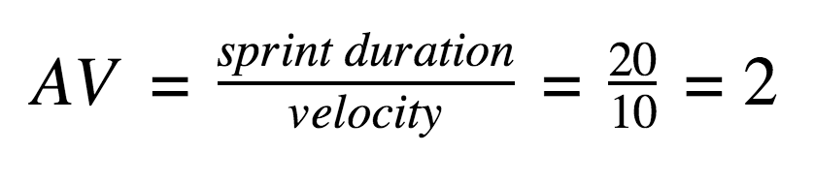

**Burndown Chart :**

